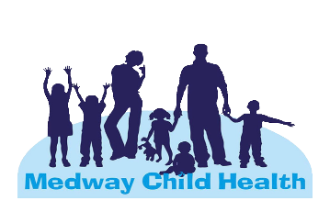
Medway Child health team support

SEN Support, Well-Being Guidance and School Nurse support
To support your children's speech, language and communication needs, SpeechLink have fast tracked the launch of their new Parent Portal. The site provides parents with free speech and language advice, resources and activities. https://speechandlanguage.info/parents.
There are many apps downloadable to use on ipads and android devices to support pupils with Dyslexia and dyslexic tendencies. Please see links below:
https://www.highspeedtraining.co.uk/hub/dyslexia-apps/
https://dyslexia-assist.org.uk/
For pupils who have difficulty with fine motor skills, please see links to the FIZZY and Clever Hands Programmes. These are recommended by occupational therapy as programmes for schools to use with assisting development of motor skills for children who find this challenging:
- https://www.ekhuft.nhs.uk/patients-and-visitors/information-for-patients/patient-information-leaflets/fizzy-leaflets/
If your child is struggling to manage their ADHD, see link for ways you can support them and places you can get help:
- https://youngminds.org.uk/find-help/for-parents/parents-guide-to-support-a-z/parents-guide-to-support-adhd/
For pupils with a need of ASD, the link below provides links to support and advice for parents and carers of autistic children, including information on living with autism and accessing services that meet family's needs:
https://www.kent.gov.uk/__data/assets/pdf_file/0006/96036/SEN-resources-to-help-you-home-educate.pdf
To support children who struggle with anxiety or mental health needs, Childline have adapted their service and resources online specifically to address worries about Coronavirus. Please find the link below:
- https://www.childline.org.uk/get-support/contacting-childline/message-from-childline/

We have other activities that you may wish to do with your children for mindfulness and emotional health and wellbeing enrichment. Please email:

childhealth@medway.gov.uk if you would like to receive more information.

For more information on child health: childhealth@medway.gov.uk

abettermedway.co.uk


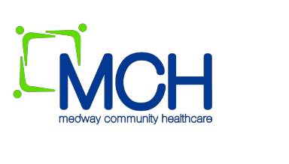


What is the school health service? Is it still operating? What can they offer me?

The school health team includes qualified nurses who have additional qualifications in Specialist Community and Public Health Nursing (School Nurses), as well as registered nurses (School Staff Nurses). We work with the local communities, the family and individual children/young people to ensure children health needs are met. We work in a range of settings including schools.

We offer health assessments to vulnerable children as well as advice and support for children and parents around health issues such as continence, behaviour, sleep and emotional health.
Our team includes Emotional Wellbeing practitioners who can offer support for emotional health needs resulting from life challenges like friendship issues, parental separation, bereavement, house move etc. We support children who are otherwise healthy but because of life circumstances need that little bit of extra support with managing their emotions; we signpost children with more complex behaviour issues or mental health concerns to NELFT and specialist services.

How can I get in touch? Each school has a named school nurse that can be contacted through our single point of access TEL: 0300 123 3444 (option 2).

Parents and children can also call this number to ask for a call back from their school nurse. Due to the restrictions put in place in schools we will offer video call or voice call advice. There is no need to put in full referral we will accept any child who needs advice or support

#stayathome #everymindmatters

