St Helen’s Church of England Primary School Science Policy
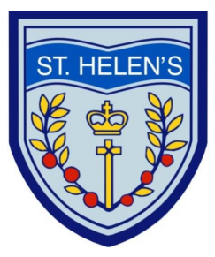
Introduction
Science teaches ways of investigating, interpreting and understanding natural and physical phenomena. At St Helen’s, the teaching of Science aims to stimulate a child’s curiosity in finding out why things happen in the way they do. It introduces methods of enquiry and investigation to stimulate creative thought in a practical way. Children learn to ask scientific questions, learn new scientific vocabulary, record and interpret their findings and begin to appreciate how Science affects their lives both now and in the future.
Aims
• to develop pupils’ enjoyment and interest in science and an appreciation of its contribution to all aspects of everyday life
• to build on pupils’ curiosity and sense of awe of the natural world
• to use a planned range of investigations and practical activities to give pupils a greater understanding of the concepts and knowledge of science
• to introduce pupils to the language and vocabulary of science
• to develop pupils’ basic practical skills and their ability to make accurate and appropriate measurements
• to develop pupils’ use of computing in their science studies.
• to extend the learning environment for our pupils via our environmental areas and the locality
• to promote a ‘healthy lifestyle’ in our pupils
The Curriculum
Foundation Stage
Science is taught in the Reception class, according to the Curriculum guidance for the Foundation Stage. It is incorporated in the Early Learning Goal ‘Understanding the World’ in which pupils develop the crucial knowledge, skills and understanding that helps them make sense of their world.
Key Stages 1 and 2
The knowledge and skills within The National Curriculum Programme of Study are met using the updated Kent Primary Science Scheme of Work and other resources considered appropriate. There are cross curricular opportunities throughout the curriculum. Topic coverage as below:
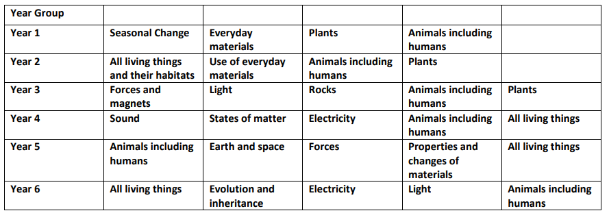
Units may be covered in any order over the year, some extended to cover more than one term. Additional topics will be covered by whole school science events/days.
Health and Safety
The safe use of equipment and materials is promoted at all times. The Association for Science Education document ‘Be safe’ has been adopted by the school as a realistic guide to primary school health and safety. A copy is available from the Science Co-ordinator. Teachers must take into account any health and safety and child protection issues; particular attention must be given to avoiding the use of anything which aggravates individual pupils’ allergies. Risk assessments are carried out to ensure safety issues have been identified and that specific attention is made when activities are unusual and beyond the scope of normal safety practice. CLEAPSS will be used, if necessary.

Additional Educational Needs
The study of science is planned and differentiated to provide pupils with a suitable range of activities and support appropriate to their abilities and needs. Curriculum planning ensures that all pupils have an equal opportunity to take part in every aspect of the Science Curriculum. Gender, disability and cultural differences are reflected positively in our school.
Assessment
Assessment opportunities will be identified within the scheme of work. Formative assessment will be an integral part of the assessment procedure. Children’s prior knowledge, understanding and skills will be reflected within the medium-term planning. On completion of each unit children are assessed as working below, exceeding or meeting expectations. Assessment grids for the scheme are completed on Arbor and will be accessed by the science lead teacher. At the end of the year the teacher will make an overall judgement to say where a child is working in relation to their age group. The vocabulary used will be emerging, expected and exceeding and will be reported to parents.
Resources
Shared resources are located in the Science cupboards, topic specific resources in the appropriate class rooms. Requests for additional/replacement resources are made to the Science lead teacher at the end of the term before they are required.
Role of the Science Lead
• To ensure complete coverage of the curriculum.
• To monitor the quality of teaching and learning of Science through book looks, lesson observations and pupil interviews.
• To monitor progress and attainment across the school.
• To manage resources.
• To review schemes of work and assessment. Policy Review
The policy will be reviewed in September 2025

